Data Stream Mining and Its Applications
Dr. Latifur Khan
Professor
Erik Jonsson School of Engineering and Computer Science
University of Texas at Dallas

lkhan@utdallas.edu
Abstract
Data streams are continuous flows of data. Examples of data streams include network traffic, sensor data, call center records and so on. Their sheer volume and speed pose a great challenge for the data mining community to mine them. Data streams demonstrate several unique properties: concept-drift, and concept-evolution. Concept-drift occurs in data streams when the underlying concept of data changes over time. Concept-evolution occurs when new classes evolve in streams. Each of these properties adds a challenge to data stream mining. This talk will present an organized picture on how to handle various data mining techniques in data streams: in particular, how to handle classification in evolving data streams by addressing these challenges. In this talk a number of applications of stream mining will be presented such as adaptive malicious code detection, on-line malicious URL detection, evolving insider threat detection and textual stream classification.
This research was funded in part by NASA and Air Force Office of Scientific Research (AFOSR).

Bio:
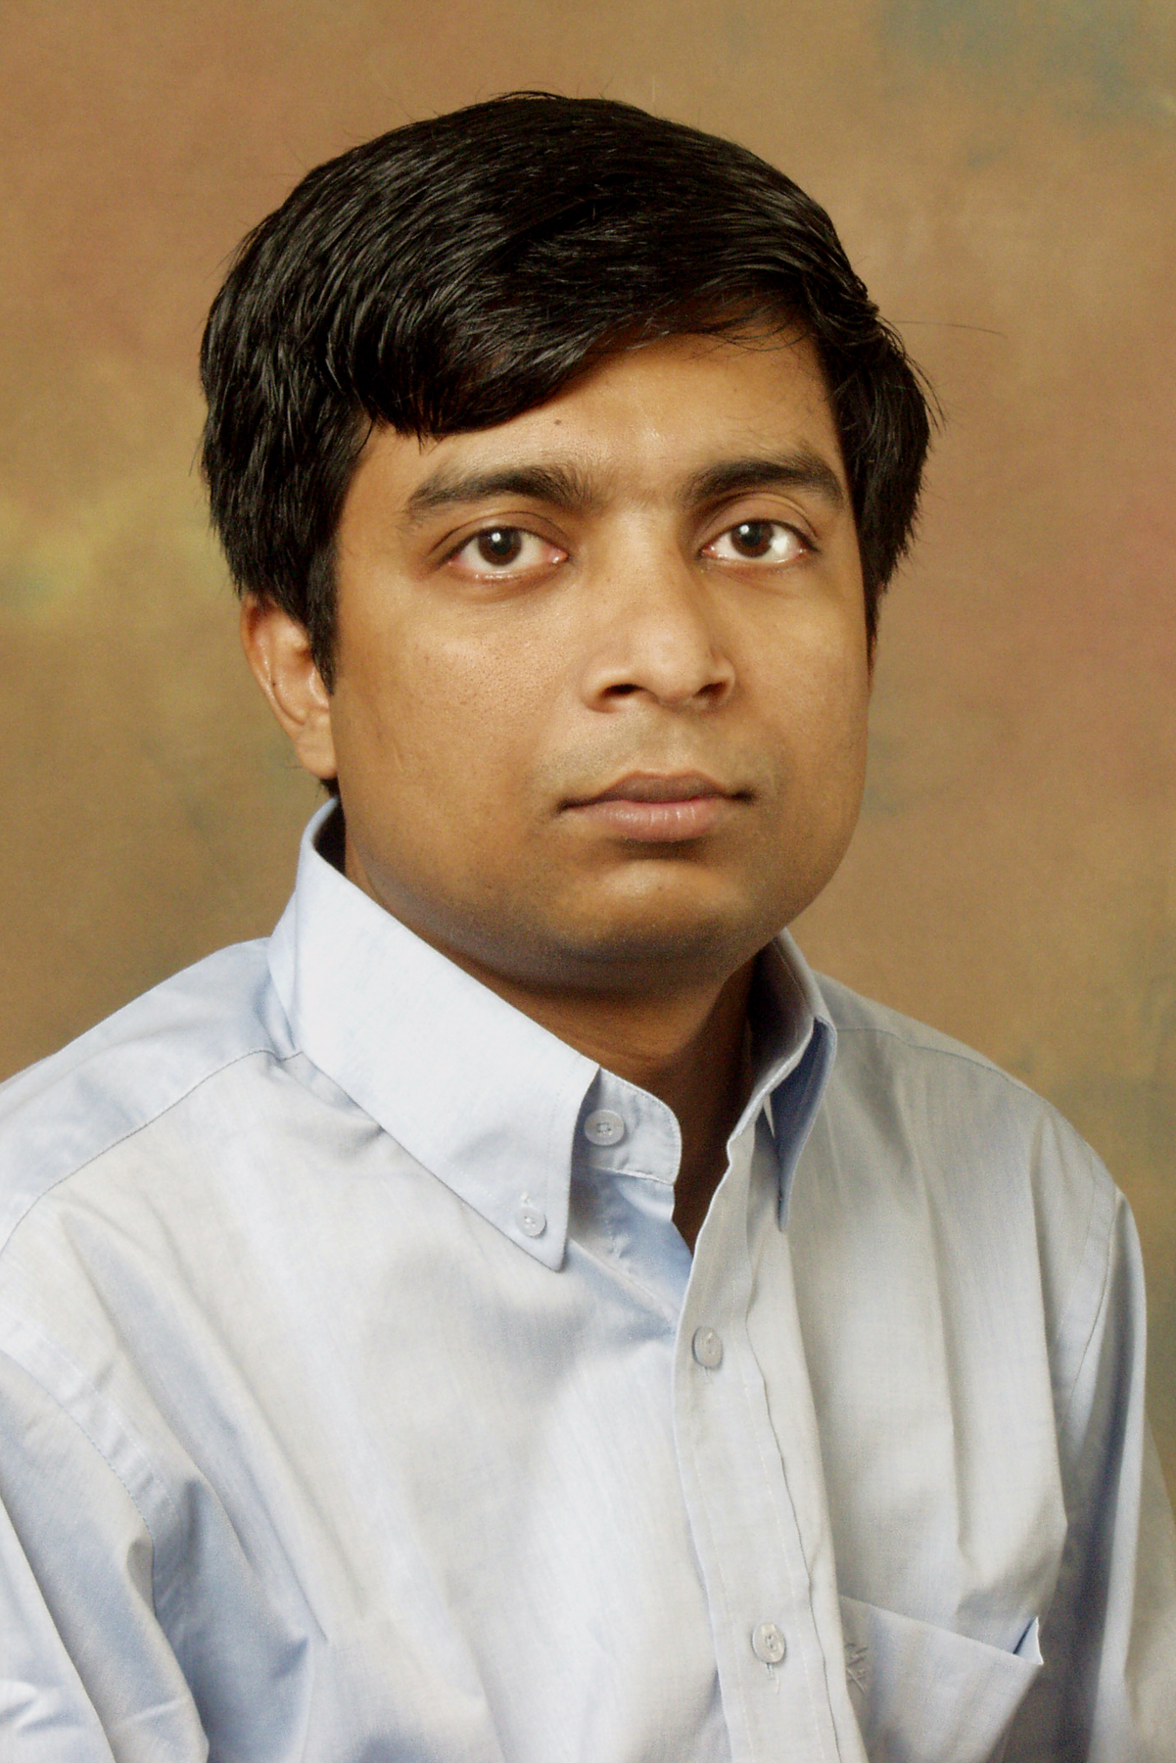
Dr. Latifur Khan is currently a Professor in the Computer Science department at the University of Texas at Dallas (UTD), where he has been teaching and conducting research since September 2000. He received his Ph.D. and M.S. degrees in Computer Science from the University of Southern California (USC), in August of 2000, and December of 1996 respectively. He obtained his B.Sc. degree in Computer Science and Engineering from Bangladesh University of Engineering and Technology, Dhaka, Bangladesh in November of 1993 with First class Honors (2nd position). He was a recipient of Chancellor Awards from the President of Bangladesh.

His research work is supported by grants from NASA, the Air Force Office of Scientific Research (AFOSR), National Science Foundation (NSF), IARPA, Raytheon, Alcatel, Tektronix, CISCO, TI and the SUN Academic Equipment Grant program. Dr. Khan's research areas cover data mining, multimedia information management, semantic web and database systems with the primary focus on first three research disciplines. As of today, eleven Ph.D. students have graduated under Dr. Khan's supervision and one of them is currently working as an assistant professor in the Computer Science department at Clemson University, USA. Other PhD graduates work in various academic institutions (UAE University) and corporations such as Microsoft, Raytheon (research) and Amazon. He also collaborates actively with researchers from MIT, UIUC, UMN, Purdue and IBM TJ Watson Research Center.

Dr. Khan is a Senior Member of ACM and IEEE. He has chaired several conferences and serves (or has served) as associate editor on multiple editorial boards including IEEE Transactions on Knowledge and Data Engineering (TKDE) journal. Recently, he has received the IEEE Technical Achievement Award from IEEE Systems Man and Cybernetics Society, and the IEEE Transportation Systems Society. He has been invited to give keynote talk at 22th International Conference on Tools with Artificial Intelligence ICTAI 2010 (special Track "Data Warehousing and Knowledge Discovery from Sensors and Streams" ), Arras, France; SUTC 2010: 2010 IEEE International Conference on Sensor Networks, Ubiquitous, and Trustworthy Computing, Newport Beach, California; and International Conference on Computer and Information Technology (ICCIT), 2006 & 2011. In addition, he has conducted tutorial sessions in prominent conferences such as ACM WWW 2005, MIS2005, DASFAA 2012 & 2007, WI 2008 and PAKDD 2011 & 2012.

